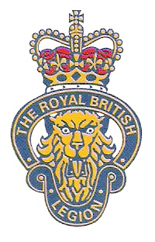

THE ROYAL BRITISH LEGION

POWICK AND CALLOW END BRANCH

CELEBRATION

CHEESE AND WINE

‘PARTY’
Commemorating
Peace 1918

And those in our community who gave so much
And the birth of the
Royal Air Force
venue
CALLOW END
VILLAGE HALL

ON
SATURDAY JUNE 16th

From 7.30pm until 11.00pm

TICKETS £6.00

Available from: ‘The Old Bush’ or JM. on 830682,
or RG. on 839756, or AC. on 830813, or VW. on 831996,
(In aid of the ‘Poppy Appeal’ and Branch funds)

